**Validation of the User ID**

**Name:Poorvi R Emp_Id:** **2500928**

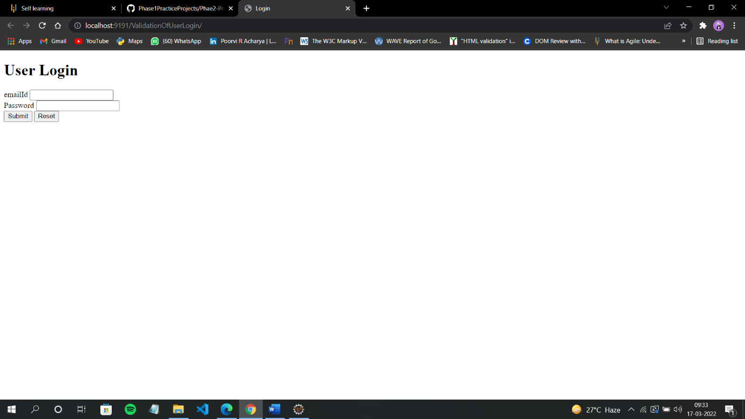 **Output of login page**

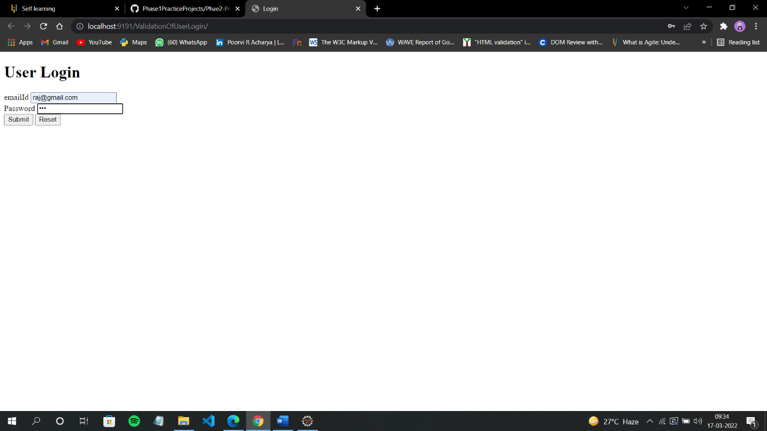 **Enter** [**emailId=raj@gmail.com**](mailto:emailId=raj@gmail.com) **and password=123**

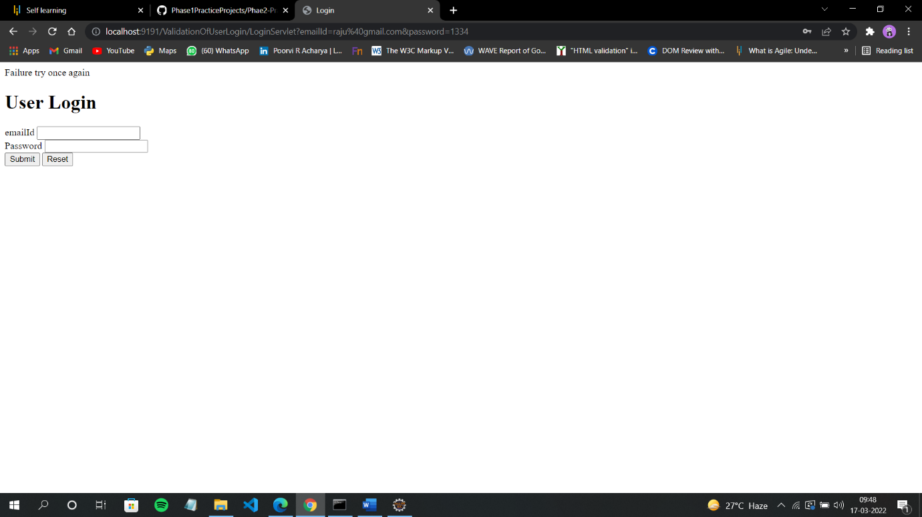**When you enter incorrect emailId or password it asks you to try once again**

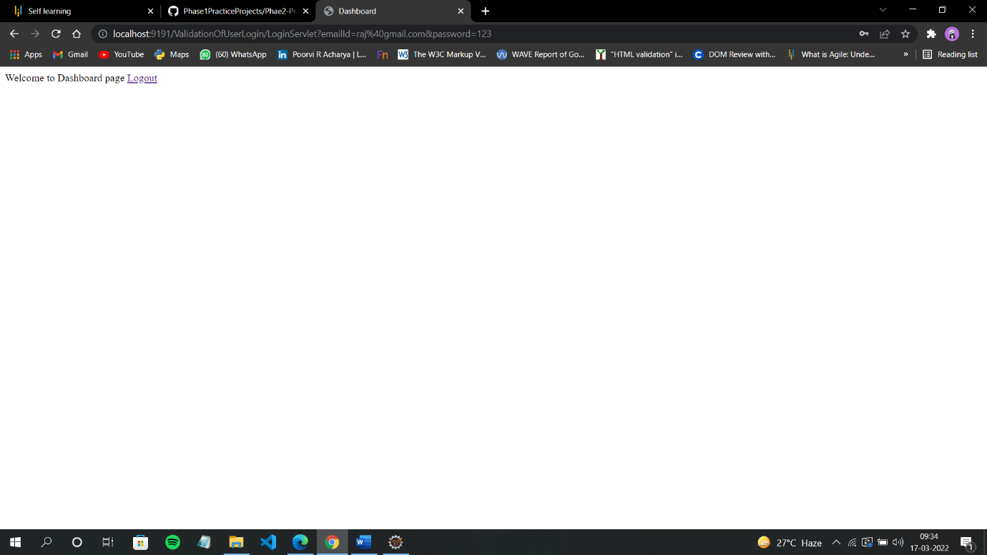

**After login Dashboard page will be shown along with logout button**

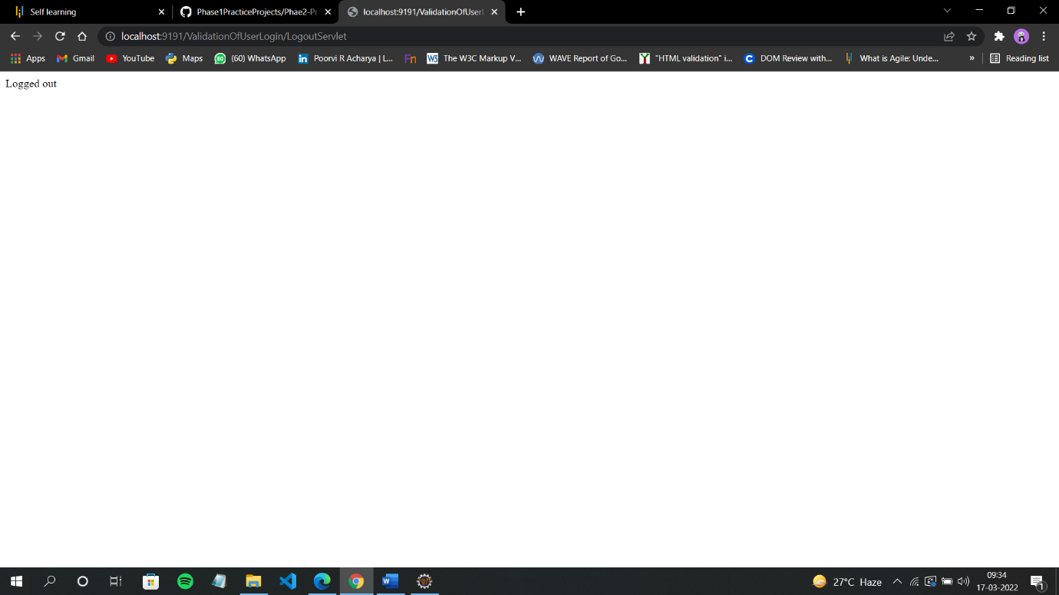**When you click on logout button you will be Logged out**